**Attenuation of the Toxic Side Effects of Statin Treatment**

|  |  |
| --- | --- |
| **Project Number:** | #1686 |
| **Principal Investigator:** | Prof. Menachem Rubinstein |
| **Patent Status:** | Pending |

**Overview**

**A method for possibly reducing or limiting the side effects of statin treatment in the muscle tissue of a patient.**

**Background and Unmet Need**

Statins are a remarkable class of drugs, showing to effectively reduce the frequency of heart attacks by 25–30%. With cardiovascular diseases on the rise globally, statins have shown themselves to be an important and valuable therapeutic intervention. However, statins are also plagued with numerous serious side effects the most prominent being myositis, rhabdomyolysis, and muscle aches.

Consequently, an estimated 5–10% of patients discontinue statin use due to the aforementioned side effects. **Therefore, there is a strong need for a method to keep patients on statin treatment but to reduce and possibly alleviate side effects.**

**The Innovation**

The technology is based on the discovery from the lab of Prof. Menachem Rubinstein, where his group has discovered a previously unrecognized pathway (MGST2-LTC4) leading to apoptosis and/or necrosis following ER stress triggered by drugs such as statins. Therefore, by inhibiting said MGST2-LTC4 pathway, it is feasible to reduce cell death, and subsequently different side effects of statins. However, the major value of inhibiting the MGST2-LTC4 pathway, is that it should not affect or compromise the desired therapeutic effects of statins.

**Technology Essence:**

Common lipid-reducing medications, such as Simvastatin, can elicit stress in the endoplasmic reticulum (ER). Said ER stress triggers increases expression of the enzyme MGST2 (microsomal glutathione-S-transferase 2), which itself generates increased production of LTC4 (leukotriene C4). ER stress also causes the nuclear translocation of LTC4 receptors, CysLTR1 and CysLTR2. Subsequently, LTC4 binds to CysLTR1 and 2 inducing the nuclear translation of NOX4 (NADPH oxidase 4), causing a large increase in the production of ROSs (reactive oxygen species) and subsequently DNA damage, leading to cell death. Therefore, inhibition of Leukotriene receptors, represent a potential point of intervention to stop cell death due to statin treatment.

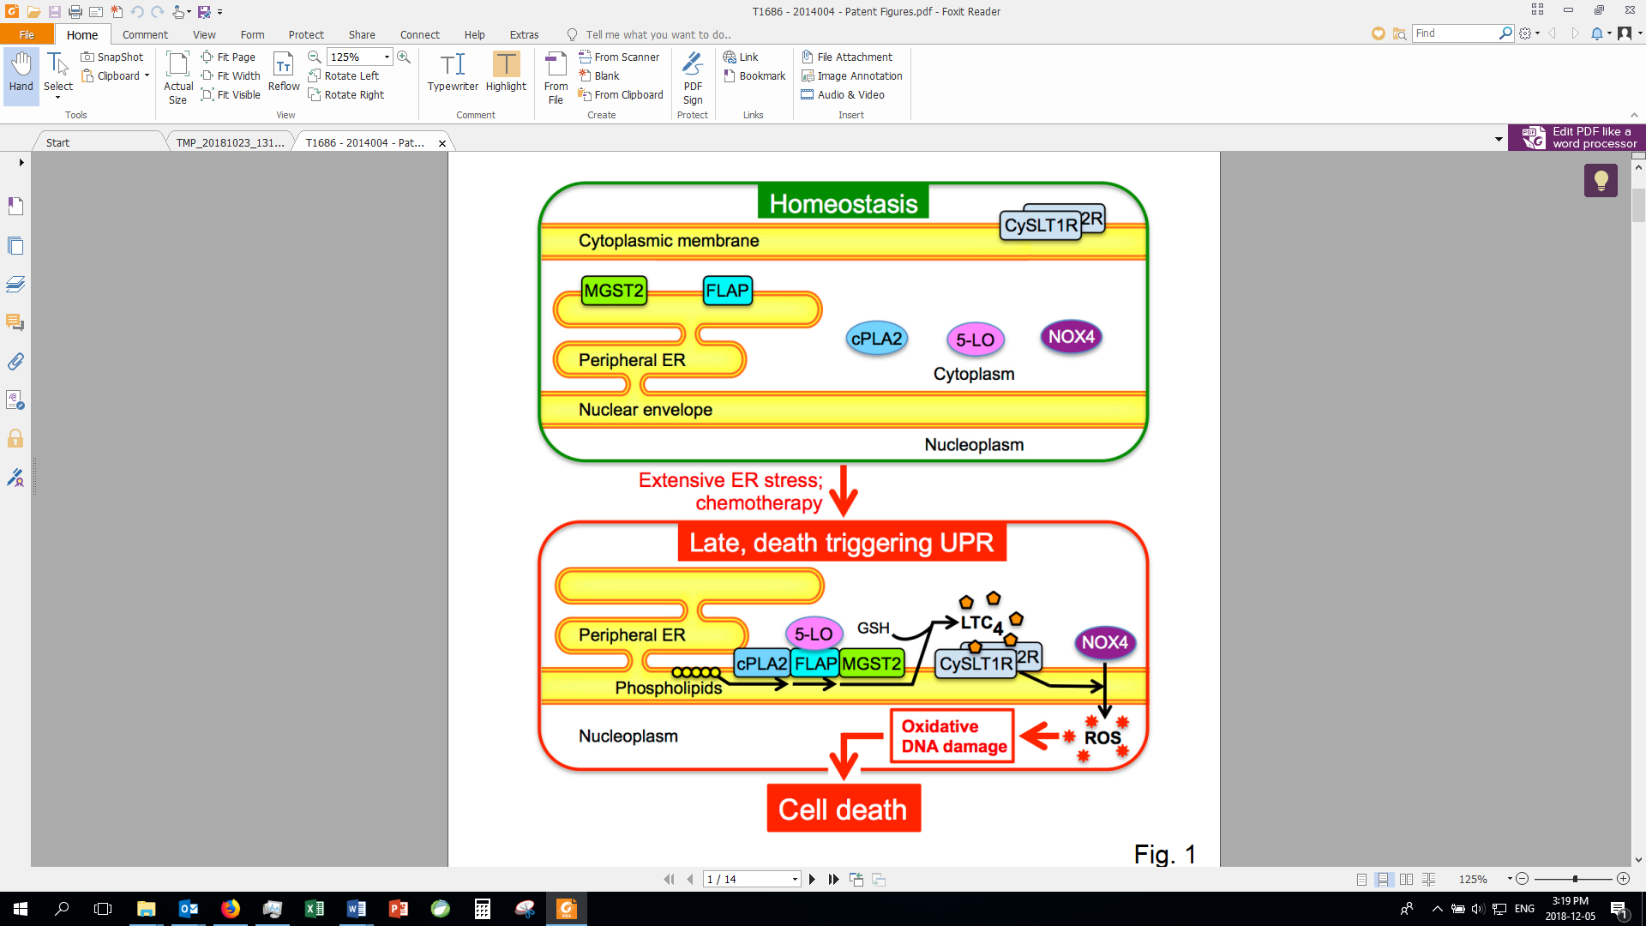

Schematic of the novel MGST2-LTC4 pathway.

***Advantages and Applications***

* Possible attenuation of side effects from statins, without compromising the efficacy of statins.
* Leukotriene receptor antagonists have already been FDA approved for treatment of allergy related indications.

**Development Status**

The Rubinstein team have discovered a novel pathway for ER induced stress and published their research in the prestigious scientific journal of Nature Communications (Dvash, Efrat, et al. 2015). They have results both *in vitro* and in multiple cell lines demonstrating the role of LTC4 in the ER stress pathway and potential for causing cell death.







**For additional information please contact:**

Dr. Shay Sela

VP Business Development Life Sciences

Tel: +972.8.9344095

Email: [Shay.Sela@weizmann.ac.il](mailto:Maya.Orlev@weizmann.ac.il)